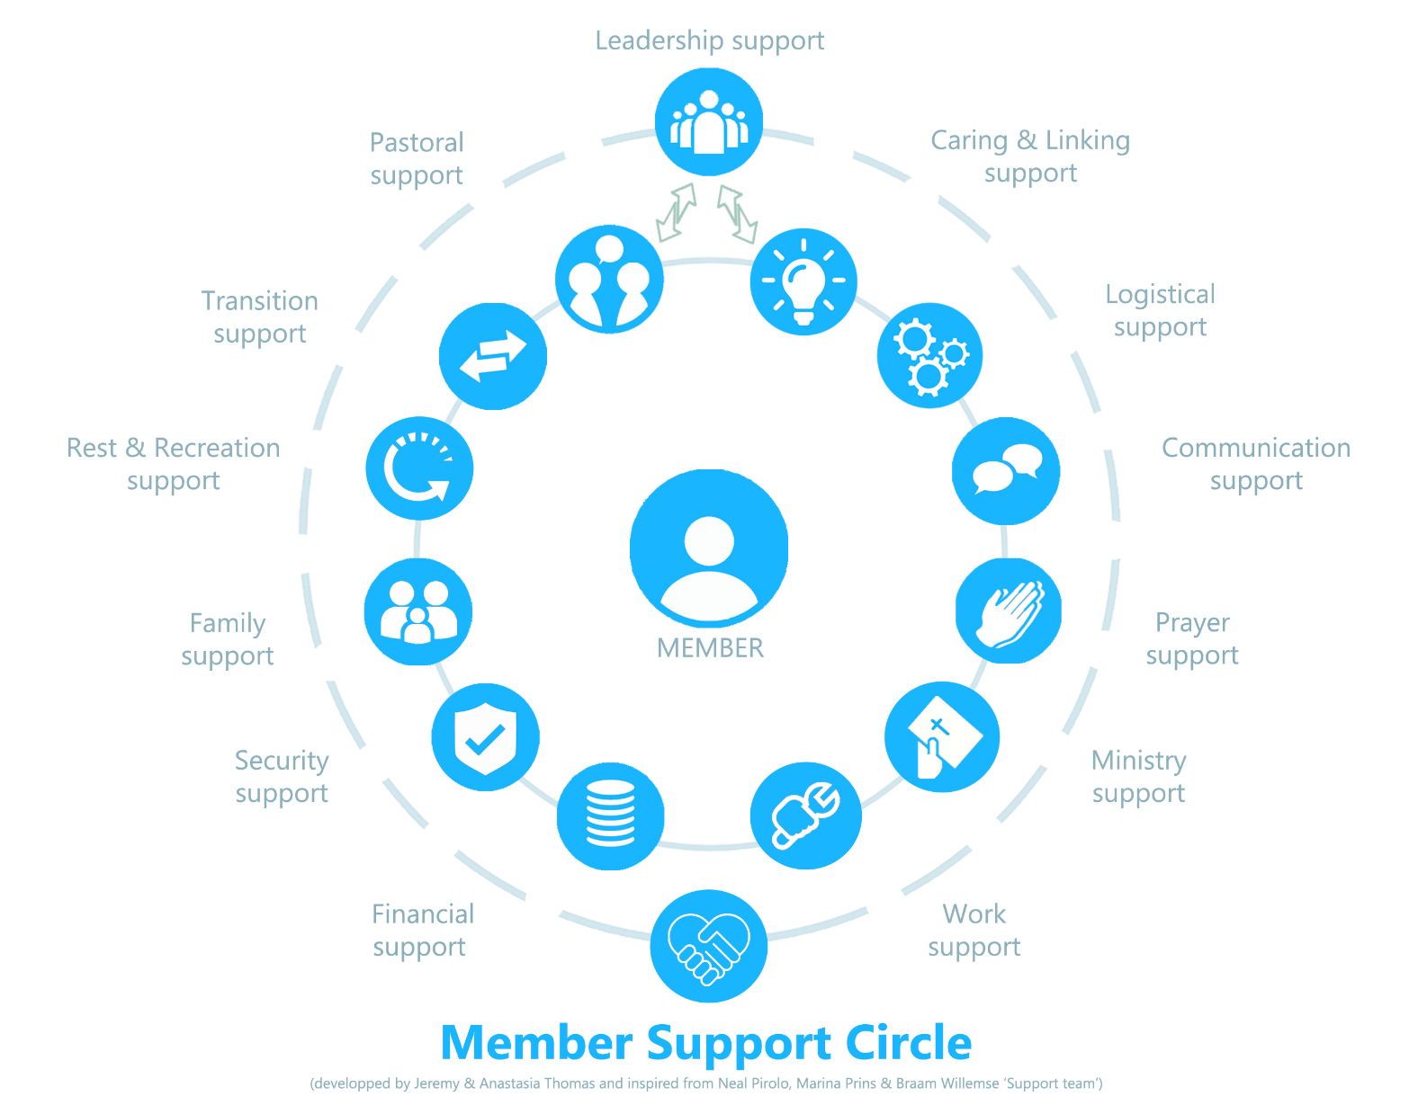

SELF-ASSESSMENT
The following 13 categories list areas where Kingdom workers usually need support through people (believers or not) they have a personal relationship and can reach out to (if possible one phone call away). Using the scales below please rate how satisfied each of the following areas were/are during the past three months. Consider the examples of possible experiences to guide your responses knowing that every area varies according to our culture, context and experiences.
Then try to put the name of at least one person (if any) you can reach out to get support when needed. Note that the same person can be your support in different areas at the same time.

Area of support | Types of support | Level of felt satisfaction (past 3 months)
Leadership  Name(s):………………………….  ……………………………………….. | Support and value my ministry, provide leadership and guidance
Pastoral  Name(s):………………………….  ……………………………………….. | Ensure that I (and my family) develop and grow spiritually, correct me (if needed)
Transition  Name(s):………………………….  ……………………………………….. | Walk alongside/ follow-up with me to process my transitions and for my mental health well-being
Rest & Recreation  Name(s):………………………….  ……………………………………….. | Friends with who I can hangout, have fun and/or rest to recharge
Family  Name(s):………………………….  ……………………………………….. | Provide a strong emotional foundation, offer practical help (such as financial assistance or childcare), serve as a source of encouragement and advice
Security  Name(s):………………………….  ……………………………………….. | Provide assistance in case of cyber, psychological or physical threat/ issue
Financial  Name(s):………………………….  ……………………………………….. | Help me manage better budgeting and banks, organize fund-raisings, financial assistance
Work  Name(s):………………………….  ……………………………………….. | Assist me/ give advice in the work that I am paid for/ receive salary from
Ministry  Name(s):………………………….  ……………………………………….. | Help me to reach my ministry goals/ objectives, get appropriate training
Prayer  Name(s):………………………….  ……………………………………….. | Get prayer requests from me and pray for me and with me, share requests with other prayer warriors (if needed)
Communication  Name(s):………………………….  ……………………………………….. | Help me to develop my communication with others (speaking, listening, newsletter, email, etc.)
Logistical  Name(s):………………………….  ……………………………………….. | Provide necessary information/ contacts I need; help with all those practical little things that can make life so difficult
Caring & Linking  Name(s):………………………….  ……………………………………….. | Ensure that I am well cared for, encouraged and linked to the resources (especially people) I need
Reference: Member support circle assessment – developed by Jeremy & Anastasia Thomas (2025)
Retrieved from https://daybreak-academy.org/resources/
Used with permission and adapted in consultation with Jeremy & Anastasia Thomas 2025.

Note: You can also use the results of this assessment to appreciate those in your life who were/are supporting you and discern who are the relationships you can be intentional to look for according to your needs. If you have a resource servant in your community, we recommend you to talk about it with him/ her.

